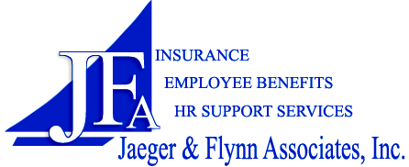
Direct Deposit Form
Fax Completed Form to: 518.792.0226 | Questions/Assistance: 866.311.7110

Complete and remit this form if opting for Direct Deposit of your reimbursements from Jaeger & Flynn Associates, or if making changes to the information already on file with JFA.

You do not need to complete this form each year at open enrollment, unless you are making a change to your bank account.

Step 1: Participant Information
Employer Name
Participant Name
Participant Social Security Number
Email Address
Step 2: financial institution information
Important Note: A voided or photocopied check is required for all checking accounts; deposit slips cannot be accepted for checking accounts. If you remit this form without a voided check copy, JFA will not be held responsible for any misdirected direct deposits as a result of incorrect information that is simply written below.
Please CHECK ONE | I am ◻ beginning ◻ canceling ◻ changing a Direct Deposit account.
Account Type | ◻ Checking ◻ Savings
Routing Number (must be 9 digits)

Account Number

Financial Institution Name & Address

Step 3: Participant authorization
I hereby certify that the information provided on this form is accurate. Further, I understand my completion and submission of this form authorizes Jaeger & Flynn Associates, Inc. to issue payment directly to the specified account unless I notify them otherwise. I understand that I will be provided with notification of the amount and date of each direct deposit made. If I have provided an email address to JFA, I understand that such notification will be made to me via email, and that neither the Plan, Employer, nor any agent of the Plan or Employer, shall be held liable for my not having received any communication by virtue of the inability to receive the communication at the email address provided. In the event funds are deposited erroneously into my account, I authorize Jaeger & Flynn Associates, Inc. to debit my account(s), not to exceed the original amount of the credit. I also understand that all direct deposits are made through the automated clearing house (ACH), and that funds availability is subject to the terms and limitations of the ACH as well as my financial institution.
Participant Signature
Date
Step 4: VOIDED CHECK/COPY
(Attach Check Copy Here)

